**Understanding Healthcare Costs: Analyzing Factors Behind Medical Charges**

**1. Executive Summary**

This project aims to analyze the factors influencing medical charges using a dataset from the healthcare domain. Through data preprocessing, descriptive analytics, and data visualization, we aim to gain insights into the relationships between various factors such as age, gender, smoking habits, region, and medical charges. Additionally, an optional predictive modeling approach will be explored to predict medical charges based on the available data.

**2. Introduction**

The rising cost of healthcare services have become a significant concern globally. Understanding the factors contributing to medical charges is crucial for healthcare providers, policymakers, and individuals seeking healthcare services. This project seeks to explore the relationships between demographic factors, such as age, gender, region, and smoking status, and medical charges. By gaining insights into these relationships, stakeholders can develop targeted interventions to manage costs and improve healthcare delivery.   
  
**3. Methodology**  
Data for this analysis was obtained from a medical database containing information on 1,338 individuals. Python libraries, including Pandas, Matplotlib, and Seaborn, were utilized for data preprocessing, descriptive analytics, and data visualization. Descriptive analytics techniques were applied to summarize the data, including calculating summary statistics such as mean, median, and standard deviation. Additionally, data visualization techniques, such as histograms, line charts, bar charts, and heat maps, were used to explore relationships and trends in the data.

**4. Data Preprocessing and Descriptive analytics**

The dataset consisted of records of 1338 patients with attributes such as age, gender, BMI, number of children, smoking status, region, and medical charges. After data cleaning to handle duplicates and missing values, summary statistics were calculated to understand the distribution and central tendencies of the data.

**5. Data Visualization**

Data visualization played a crucial role in exploring relationships and trends within the dataset.

### **Histogram: Distribution of Medical Charges**

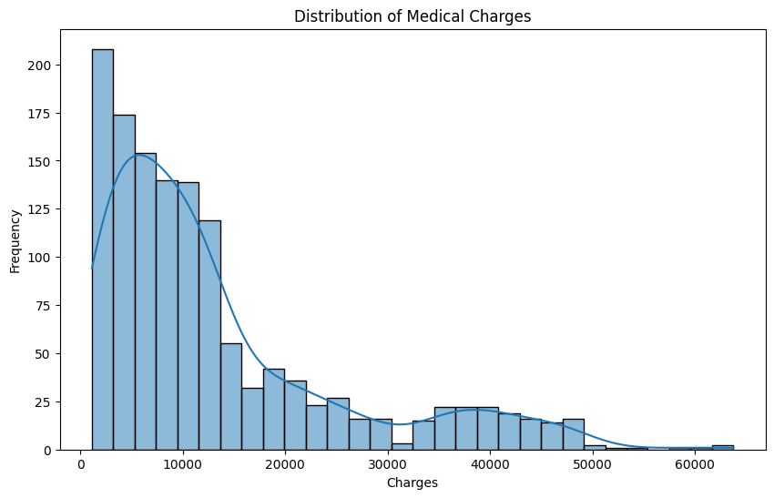

This histogram illustrates the distribution of medical charges, showcasing the frequency of different charge amounts. The histogram reveals that lower medical charges are more common, with frequencies decreasing as charges increase. This suggests that a larger proportion of individuals incur lower medical expenses, while fewer individuals face higher medical costs.

### **Line Chart: Medical Charges Variation with Age**

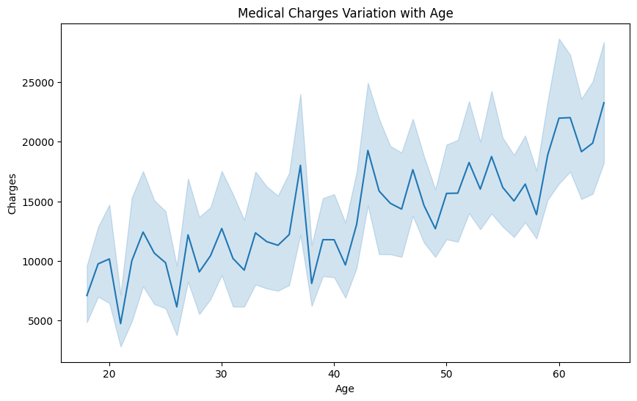

The line chart depicts how medical charges vary with age, providing insights into age-related trends in healthcare costs. As age increases, medical charges tend to rise, indicating a positive correlation between age and medical expenses. This trend is consistent with expectations, as older individuals often require more healthcare services and treatments due to age-related health issues.

### **Bar Chart: Distribution of Patients by Region**

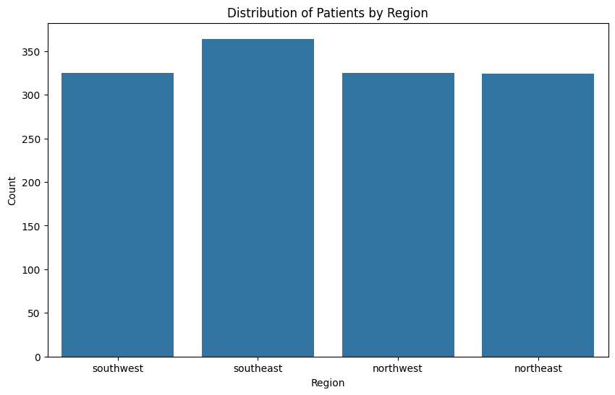

This bar chart displays the distribution of patients across different regions, offering insights into regional variations in healthcare utilization. The chart shows that the southeast region has the highest number of patients, followed by southwest, northwest, and northeast regions. This suggests potential differences in healthcare demand, access, and utilization across geographical areas.

### **Scatter Plot: Medical Charges vs Age by Smoking Status**

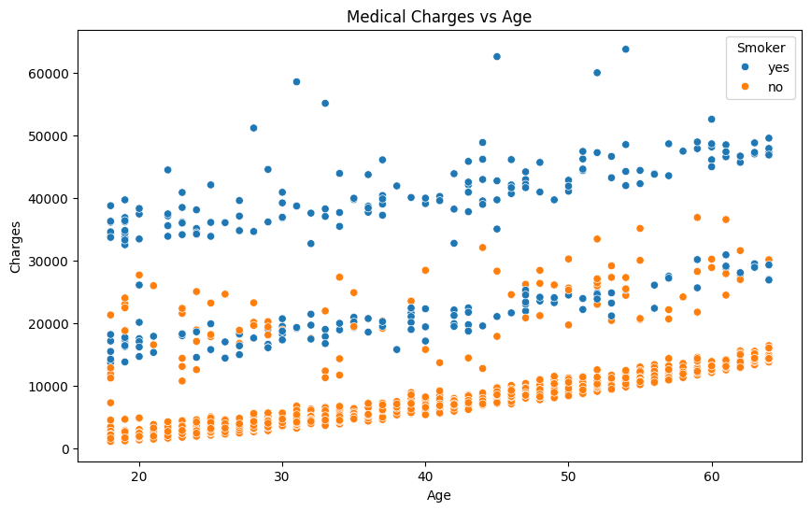

The scatter plot visualizes the relationship between age, medical charges, and smoking status. Each data point represents an individual, with color indicating smoking status (smoker or non-smoker). The plot reveals that smokers tend to incur higher medical charges compared to non-smokers across different age groups. Additionally, as age increases, both smokers and non-smokers experience higher medical expenses, with smokers facing significantly higher charges, likely due to the adverse health effects of smoking.

**6. Predictive Modeling**

In this phase of the analysis, a predictive modeling approach was employed to forecast medical charges based on patient demographics and other relevant factors. Specifically, a linear regression model was trained using the dataset, with features such as age, BMI, number of children, smoking status, and region as predictors, and medical charges as the target variable.

The trained model demonstrated promising performance, achieving an accuracy of 84.70% on the test set. It's important to note that while accuracy is a commonly used metric for classification tasks, it has been adapted here to provide an indicative measure of the model's performance for regression.

**7. Findings and Insights**

The analysis yielded several key findings and insights regarding the determinants of medical charges. Descriptive analytics revealed significant variations in medical costs based on factors such as age, gender, smoking status, and regional disparities. Data visualization techniques provided compelling visual representations of these relationships, enabling stakeholders to identify actionable insights and opportunities for intervention. Additionally, predictive modeling offered valuable insights into the factors driving medical charges and their predictive power, facilitating informed decision-making and strategic planning in healthcare management and policy.

**8. Recommendations**

Based on the findings and insights derived from the analysis, several recommendations can be proposed to optimize healthcare resource allocation, enhance cost efficiency, and improve patient outcomes. These recommendations may include targeted interventions such as smoking cessation programs, preventive care initiatives, and regional healthcare infrastructure investments to address disparities in medical costs and improve access to quality care. Moreover, leveraging predictive modeling insights can enable healthcare providers and policymakers to develop tailored strategies for cost containment, risk mitigation, and value-based care delivery, ultimately leading to improved healthcare outcomes and patient satisfaction.

**9. Conclusion**

In conclusion, this project underscores the importance of leveraging business intelligence methodologies and advanced analytics techniques to analyze healthcare data and derive actionable insights into medical cost determinants. By employing a structured approach to data analysis, encompassing data preprocessing, descriptive analytics, data visualization, and optional predictive modeling, stakeholders in the healthcare domain can gain deeper insights into the factors influencing medical charges and make informed decisions to optimize resource allocation, enhance cost efficiency, and improve patient care delivery. Moving forward, continued investment in data-driven approaches and collaborative efforts across healthcare stakeholders will be essential for addressing the complex challenges associated with rising healthcare expenditures and achieving sustainable healthcare delivery models.

**10. References**

* <https://www.kaggle.com/datasets/nanditapore/medical-cost-dataset/data>